Programming

For Computer Games

Assignment

**Question 1:**

1. Two game engines are, Unity and Construct.

Four reasons why Unity is used:

* Unity gives you more flexability, due to Scripting, you can either use Mono, which is included with Unity or use a program of your choice. You can choose between java or c#. while construct is simply drag and drop.
* You can create both 3D and 2D games using Unity while in construct you can only create 2d Games.
* You can download assets from the asset store of unity itself to use them to your project. While construct doesn’t have an asset store.
* Unity also enables systematic tweaking and de-bugging processes at runtime.

1. Two programming languages are, C# and java.

Four features of C#:

* C# is Object-orientated
* Compiled languages which mean that before being executed on a PC or server the code is converted to binaries.
* Compiler warnings, C# gives you compiler errors and warnings in order to avoid making serious errors.
* C# is ideally used for desktop, web and mobile applications.

**Question 2:**

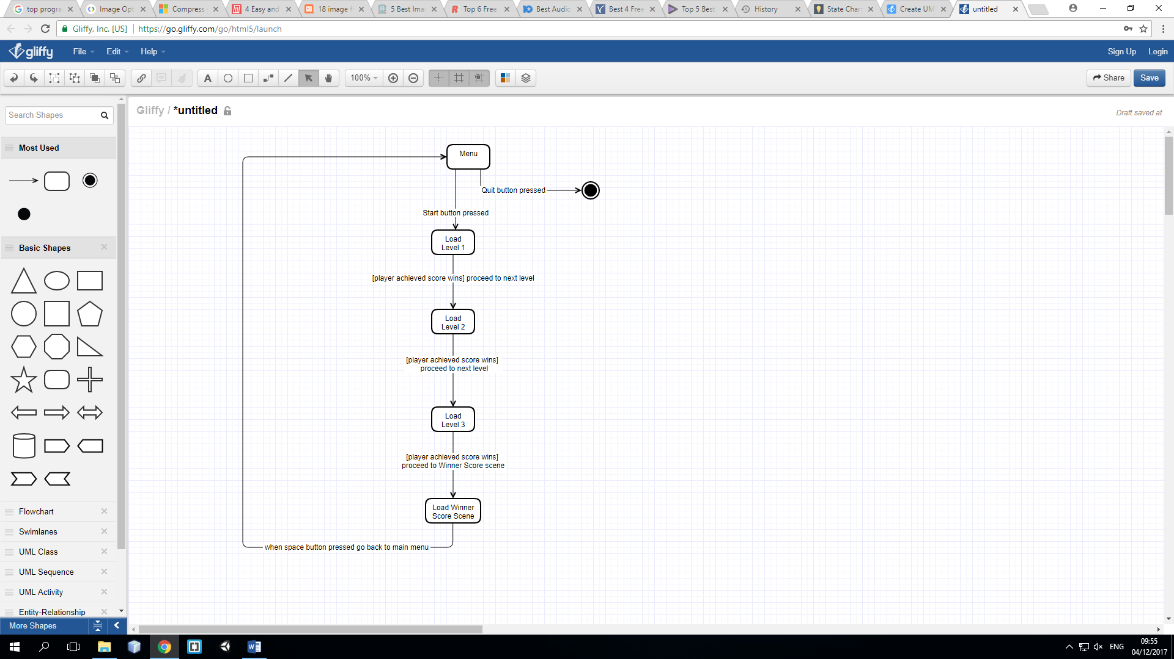

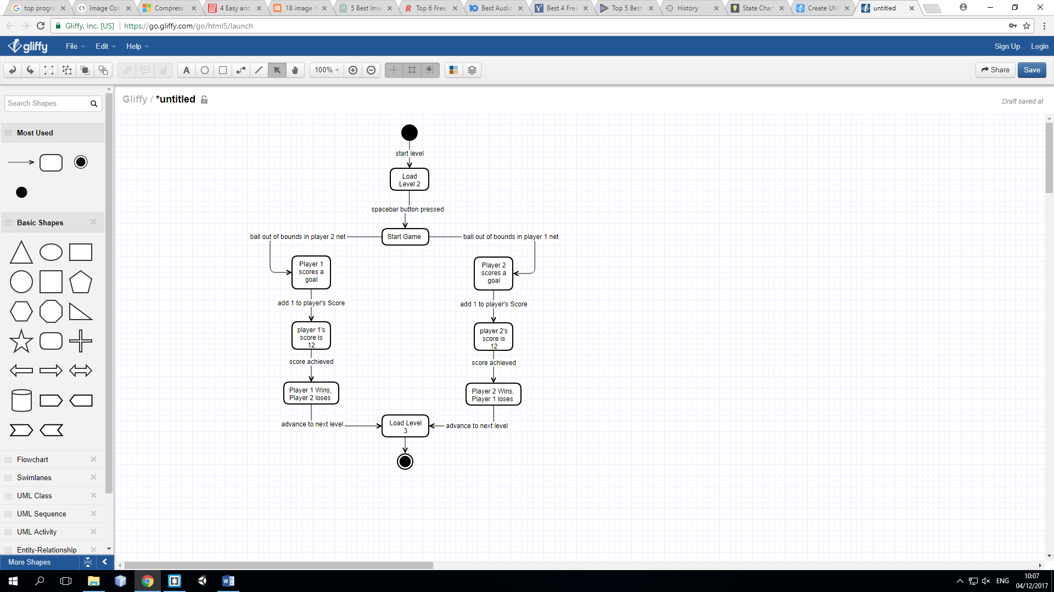

**Question 3:**

Compression is needed when using media assets. When you are compressing media asset the size of the media asset would decreases and becomes much smaller in size. For example when a compress media file is implemented in a game and all duplicate files are removed the game would load faster since the size of the media file is reduced. When compressing an image you can choose between jpeg, gif and png for smaller image size, when you are compressing to one of these three formats you must consider that jpeg is a lossy image compression while png and gif are lossless. If a video file is big in size and one needs to implement to a game, website or something else he should compress it to mp4, by compressing to mp4 the size of the file would be reduced. Some tools used to compress media assets are:

* PNGGuantlet, InfraView , compressor.io and caesium(for images)
* Online Audio Converter, Monkey’s Audio, Audacity and Advanced Audio Compressor(for audio files)
* Format Factory,HandBrake, Wondershare Video Converter and Windows Movie Maker (for video files)

# References

Dillman, A., 2017. *https://www.rev.com.* [Online]   
Available at: https://www.rev.com/blog/top-6-free-paid-tools-for-compressing-audio-files/  
[Accessed 29 11 2017].

Marsh, J., n.d. *https://www.upwork.com/hiring/development/c-sharp-vs-c-plus-plus/.* [Online]   
Available at: https://www.upwork.com/hiring/development/c-sharp-vs-c-plus-plus/  
[Accessed 27 11 2017].

Pathak, S., 2016. *techoize.com.* [Online]   
Available at: https://www.techoize.com/5-best-image-compression-tools/  
[Accessed 1 12 2017].

Smith, C., 2017. *https://videoconverter.wondershare.com.* [Online]   
Available at: https://videoconverter.wondershare.com/compress/free-mp4-compressors.html  
[Accessed 29 11 2017].

Varalakshmi, J., 2017. *whatvwant.com.* [Online]   
Available at: https://www.whatvwant.com/best-free-video-compression-software/  
[Accessed 29 11 2017].